Remarks
Democratic Caucus
November 7, 2024

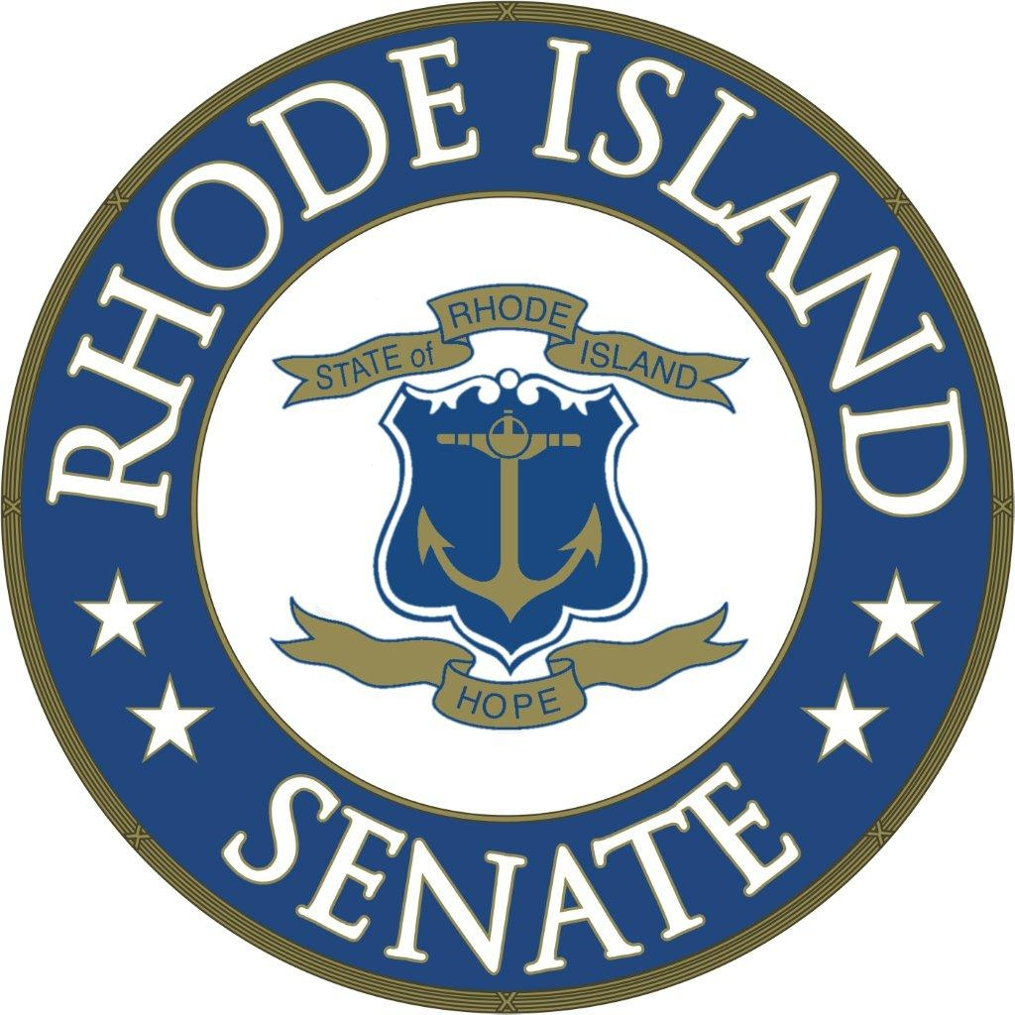

Sen. Dominick J. Ruggerio

Thank you, David and Melissa … and thank you to all of my colleagues. It is truly humbling to receive the endorsement of this Caucus to serve another term as your Senate President.

I have tremendous respect and admiration for everyone in this room.

The members of this Chamber are leaders of excellence and dedication, each of you committed to making our state an even greater place to live and work.

I am honored to serve alongside all of you.

I also want to join in welcoming our new members to the Chamber.

Congratulations to them, and to all of you, on your election victories, and I look forward to working together.

It is no secret that I’ve had a challenging spring and summer.

I want to thank all of you for your concern and your encouragement throughout that process.

To say that I have been heartened by the outpourings of support I received would be an understatement. It has been overwhelming, and I deeply appreciate it.

I am feeling so much better – and each day I get a little stronger on my journey to a full recovery.

I also know that the past month has not been easy on any of you. Thank you for your patience throughout this process.

Now, the elections are behind us.

For the sake of our beloved Senate institution, and for the sake of our constituents … it is time to move past our differences and to come together to work on the many issues facing our state.

While we have no monopoly on good ideas – and I look forward to working with all of the leaders in this room to strengthen our state – I do want to highlight some of the areas we are focused on going in to the 2025 session.

Last year, this chamber led the way in addressing our health care crisis. While much was done, considerable work remains.

A chief focus for us remains on requiring a rate review process, particularly for primary care providers.

As Senator Pam Lauria and others have noted, even primary care providers are having a difficult time finding a primary care provider.

The commission was sponsored by Senator Susan Sosnowski, who is also a member, and it is being chaired by Senator Lauria.

Additionally, the work of the commission examining the primary care provider workforce is well underway.

As part of its mission, this commission is examining the feasibility of a medical school at URI.

We need to ensure that private insurance reimbursement rates are not lower than the Medicaid rate … and that it is the consumers who receive the total value of prescription drug assistance to afford their treatments, as Senator Robert Britto proposed in legislation that was part of the Senate’s RI HEALTH Initiative last session.

We must find an appropriate, permanent revenue stream to fund the Psychiatric Resource Network, which treats children and new parents … and graduate students who perform services should be entitled to Medicaid reimbursement, as proposed by Sen. Alana DiMario.

I look forward to working together with all of the members of the Senate on these proposals, and many other ways in which we can improve our health care system.

The Senate will also continue to lead on environmental issues.

The plastic waste commission is conducting its work under the chairmanship of Senator Mark McKenney.

And Senator Sam Zurier is proposing a new commission to monitor implementation of the Act on Climate.

We will push to fully fund the EC4 – the Executive Climate Change Coordinating Council – so that it can do its vital work … and our efforts will continue as we work to reform and improve the Coastal Resources Management Council.

The final area I want to touch upon tonight is the budget.

We are expecting a tighter budget cycle than we have experienced in several years.

It is important that we maintain the initiatives fought for by the members of this chamber and relied upon by Rhode Islanders, and that we continue to work for initiatives and investments that improve our economic competitiveness.

We have been through difficult budgets before … and these goals are possible.

Rhode Island residents and businesses depend upon the relief we have provided in recent years … from elimination of the car tax to the new tangible tax exemption championed by Senator Melissa Murray.

At the same time, we need to continue investing in job training and improving our career pathways, such as through Senator Hanna Gallo’s CTE Pipeline legislation.

And we will work to enact legislation that protects consumers, including enactment of Senator Linda Ujifusa’s “junk fee” bill.

In closing, I want to offer a heartfelt congratulations to our new Majority Leader, Val Lawson. You are a dedicated and principled leader who will help advance the priorities of all the members of this Chamber.

I look forward to working alongside you, in partnership with all the members of our Chamber … as a strong and unified Senate … in the upcoming session.

